Software Requirement Specifications
IUB Complaint Management System



Submitted by
Irfan Siddique (S23BINFT1M01065)

Submitted to
Dr. Rizwan Ali Shah

Department of Information Technology
Faculty of Computing
The Islamia University of Bahawalpur

Meeting Details
Sr No | Details | Date | Supervisor Signature
Summary
The IUB Complaint Management System is a mobile application for Android and iOS that allows university students to sign up and log in using their official university email (rollno@iub.edu.pk). After login, students can register complaints under fixed categories and view them on a dashboard with their current status. Each complaint is created with a default “Pending” status and can be tracked through its lifecycle. Students can also edit or delete their complaints at any time, regardless of the complaint status. The system includes an admin module where authorized staff can view all student complaints in one place. Admins can update complaint statuses (Pending, In Progress, Resolved, Rejected) and optionally add remarks for better communication. Firebase is used as the backend for authentication (email/password with verification link) and complaint data storage.

Table of Contents
1. Introduction 5
1.1. Purpose 5
1.2. Scope 6
1.3. Product Perspective 6
1.4. User Characteristics 6
1.5. Similar apps and systems/Literature Review 7
1.6. Proposed Technologies 7
2. Requirements 8
2.1. Function Requirements 8
2.1.1. Sign Up 8
2.1.2. Login 8
2.1.3. Admin account creation 9
2.1.4. Create complaint 9
2.1.5. View complaints 10
2.1.6. View complaint detail 10
2.1.7. Edit complaint 10
2.1.8. Delete complaint 11
2.1.9. Admin view all complaints 11
2.1.10. Admin update complaint status 12
2.1.11. Maintain status history 12
2.2. Non-Functional Requirements 12
3. Use Cases and Flow of Processes 14
3.1. Use Case 1 15
3.2. Use Case 2 17
3.3. Use Case 3 19
3.4. Use Case 4 21
3.5. Use Case 5 23
3.6. Use Case 6 25
3.7. Use Case 7 27
3.8. Use Case 8 30
4. References 32

- Introduction
  - Purpose
The purpose of this Software Requirements Specification (SRS) is to clearly define the requirements of the IUB Complaint Management System mobile application and provide a complete understanding of what the system will do and how it will be used. This document describes the features available to students for submitting, viewing, editing, deleting, and tracking complaints, and the features available to admins for monitoring all complaints and updating their statuses. The SRS will act as a guideline for the development process by outlining functional requirements, data needs, and quality attributes such as security and usability. It will also help ensure that all stakeholders (developers, supervisors, testers, and future maintainers) share the same expectations about the system’s behavior, scope, and limitations before implementation and testing.
  - Scope
The IUB Complaint Management System is a mobile app (Android and iOS) that enables students to:
- Register and log in using email/password with email verification via link.
- Submit complaints under fixed categories with details (and optional attachments).
- View complaints in a dashboard and track their current status.
- Edit or delete their complaints at any time (in all statuses).
The system also enables admins to:
- View all submitted complaints from all students.
- Filter/search complaints by status, category, and student information.
- Update complaint statuses (Pending, In Progress, Resolved, Rejected) and optionally add remarks.

  - Product Perspective
This application is designed as a centralized complaint-handling platform for The Islamia University of Bahawalpur (IUB). It replaces or improves manual methods such as paper applications, office visits, phone calls, or informal social media messages by providing a structured and trackable workflow. The system uses Firebase as a backend service for authentication and data storage, making it scalable and accessible without managing a traditional server. The app will be used by two main roles: students (complaint submission and tracking) and administrators (complaint resolution and monitoring).
  - User Characteristics
Students
- Primary users who submit complaints.
- Have basic smartphone experience (Android/iOS).
- Use official university email format (rollno@iub.edu.pk).
- Need a simple interface to submit complaints and track progress.
Administrators
- University staff responsible for monitoring and resolving complaints.
- Need access to all complaint records and management controls.
- Require filtering/searching options to handle large volumes of complaints efficiently.
- Must be able to update complaint status and add remarks.

  - Similar apps and systems/Literature Review
Complaint management systems are widely used in universities and organizations to streamline issue reporting and resolution. Commonly observed features in similar systems include user authentication, categorized complaint submission, complaint tracking, administrative dashboards, and status-based workflows. Many institutions use “ticketing” style systems where each complaint acts like a support ticket that moves through statuses such as pending, in progress, and resolved. Commercial and public-sector complaint portals also emphasize transparency, faster response time, and proper record-keeping through audit trails. Compared to generic ticketing systems, this proposed app focuses specifically on the university context by limiting access to verified university email users and using fixed categories relevant to campus services.
  - Proposed Technologies
Mobile App Development
- Flutter (recommended for one codebase for Android + iOS)
Alternative: React Native
Backend (BaaS)
- Firebase Authentication (Email/Password + Email Verification Link)
- Cloud Firestore (complaints, users, status history)
- Firebase Storage (optional attachments)
- Firebase Cloud Functions (optional: automation like status-change logs, notifications)
- Firebase Cloud Messaging (FCM) (optional: push notifications)

- Requirements
  - Function Requirements
    - Sign Up
- Name: FR001
- Purpose: Sign up is required for a student to become a registered member of the system and access complaint services.
- User(s): Student
- Pre-Conditions:
  - Student has an active IUB email account.
  - Internet connection is available.
- Input:
  - Full Name: Student’s actual name.
  - Email: Must be a valid IUB email in UI validation (e.g., rollno@iub.edu.pk).
  - Password: Minimum 8 characters (recommended: include number and special character).
- Process/Rules:
  - System creates account using Firebase Authentication (Email/Password).
  - System sends email verification link to the provided email.
- Output:
  - Student account is created.
  - Verification email is sent.
  - Student can proceed to login, but app features may remain restricted until email is verified.
    - Login
- Name: FR002
- Purpose: Login is required to authenticate the student and provide access to the complaint dashboard and features.
- User(s): Student
- Pre-Conditions:
  - Student is already registered (FR001).
- Input:
  - Email: Student IUB email.
  - Password: Account password.
- Process/Rules:
  - System authenticates via Firebase Authentication.
  - System checks whether email is verified.
- Output:
  - If credentials are correct and email is verified: user is logged in and redirected to dashboard.
  - If email is not verified: user is redirected to “Verify Email” screen/message.
  - If credentials are incorrect: error message displayed.
    - Admin account creation
- Name: FR003
- Purpose: Admin accounts are required to manage all complaints and update their statuses.
- User(s): Admin (created by developer/system owner)
- Input:
  - Admin Email: Valid email (recommended: official IUB email).
  - Role: Must be set to admin in database (Firestore).
  - Admin UID: Linked with Firebase Auth UID (if admin logs in using Firebase Auth).
- Process/Rules:
  - Admin record is inserted directly into Firestore (manual process).
- Output:
  - Admin can access admin module after login.

    - Create complaint
- Name: FR004
- Purpose: Students must be able to register a complaint to report an issue related to university services.
- User(s): Student
- Pre-Conditions:
  - Student is logged in (FR002).
  - Student email is verified.
- Input:
  - Title: Short heading of complaint (required).
  - Category: Selected from fixed list (required).
  - Description: Detailed complaint text (required).
  - Attachment: Optional (image/pdf).
- Process/Rules:
  - System saves complaint to Firestore.
  - Default status set to Pending.
  - createdAt timestamp generated automatically.
- Output:
  - Complaint is stored successfully and appears in student dashboard.

    - View complaints
- Name: FR005
- Purpose: Students must be able to view all of their submitted complaints and track their statuses.
- User(s): Student
- Pre-Conditions:
  - Student is logged in.
- Input:
  - Filter (optional): Status/category/date.
- Output:
  - List of student’s complaints showing title, category, status, and date.
    - View complaint detail
- Name: FR006
- Purpose: Students and admins must be able to view complete details of a complaint for tracking and resolution.
- User(s): Student, Admin
- Pre-Conditions:
  - User is logged in.
  - Student can only open their own complaint.
- Input:
  - Complaint ID / Selected complaint
- Output:
  - Full complaint data (title, category, description, attachment, status, timestamps, remarks/history).
    - Edit complaint
- Name: FR007
- Purpose: Students must be able to correct or update complaint information after submission.
- User(s): Student
- Pre-Conditions:
  - Student is logged in.
  - Complaint belongs to the logged-in student.
- Input:
  - Updated title/category/description/attachment (any editable fields).
- Process/Rules:
  - Updates are saved in Firestore with updatedAt timestamp.
- Output:
  - Complaint is updated and changes reflect in dashboard and details screen.
    - Delete complaint
- Name: FR008
- Purpose: Students must be able to remove a complaint from the system if needed.
- User(s): Student
- Pre-Conditions:
  - Student is logged in.
  - Complaint belongs to the logged-in student.
- Input:
  - Delete confirmation (Yes/No).
- Process/Rules (choose one in implementation):
  - Soft delete: set isDeleted = true (recommended), OR
  - Hard delete: remove record from Firestore.
- Output:
  - Complaint no longer appears in student dashboard (and is removed/hidden in database).
    - Admin view all complaints
- Name: FR009
- Purpose: Admin must be able to monitor and manage all complaints submitted by students.
- User(s): Admin
- Pre-Conditions:
  - Admin is logged in and role=admin.
- Input:
  - Filters/search (optional): status, category, student email, date.
- Output:
  - List of all complaints with details summary and current status.

    - Admin update complaint status
- Name: FR010
- Purpose: Admin must be able to update complaint status to reflect progress and final resolution.
- User(s): Admin
- Pre-Conditions:
  - Admin is logged in.
- Input:
  - Complaint ID
  - New Status: Pending / In Progress / Resolved / Rejected
  - Remarks: Optional text
- Process/Rules:
  - System updates complaint status in Firestore.
  - System writes status change entry to complaint history.
- Output:
  - Status is updated and visible to student on dashboard/detail screen.

    - Maintain status history
- Name: FR011
- Purpose: The system should keep a history of status changes for transparency and tracking.
- User(s): Admin, Student (view-only)
- Pre-Conditions:
  - Complaint exists.
- Input:
  - Status change event (triggered by admin update).
- Output:
  - A history record with old status, new status, timestamp, admin identity, and remarks (if any).

  - Non-Functional Requirements

Security: The application must ensure strong security by using Firebase Authentication for all user sign-in activities and by enforcing role-based access through Firestore security rules. A student should only be able to access and modify their own complaints, while an admin should have access to all complaints for management purposes. All data communication should be protected through secure channels provided by Firebase, and the system should prevent any unauthorized access to complaint records.

Performance: The app should provide acceptable response time under normal conditions. Common operations such as loading the dashboard, opening complaint details, and submitting or updating a complaint should be performed quickly, and the app should use efficient database queries (such as pagination and indexed filters) to avoid delays when the number of complaints grows.

Reliability and Data Consistency: The system must store complaint data reliably in Firestore so that submitted complaints are not lost and remain consistent. If a network failure occurs during an operation, the app should inform the user and allow retry without corrupting data. Status updates should remain consistent across student and admin views, and status history (if implemented) should accurately reflect changes over time.

Availability: The application should be available for use at all times as it is intended for students and staff who may need to submit or manage complaints at any hour. The system should be accessible 24/7 except during planned maintenance or outages of dependent services such as Firebase, and the app should show appropriate messages when services are temporarily unavailable.

Usability: The app must be simple and easy to use for students and administrators with basic smartphone knowledge. The interface should be clean, navigation should be straightforward, and forms should provide clear validation messages. Complaint statuses should be displayed in an understandable way, and the app should guide users properly through signup, email verification, complaint submission, and tracking.

Maintainability: The project should be developed in a structured and modular way so future updates, bug fixes, and feature additions can be made easily. Code should be organized into clear components (UI, business logic, Firebase services), and basic documentation should be maintained to help future developers understand the system.

Scalability: The system should be able to handle increasing numbers of users and complaints without significant performance degradation. This should be achieved by using efficient Firestore data structures, query limits/pagination for large lists, and appropriate indexing for commonly used filters such as status and category.

- Use Cases and Flow of Processes
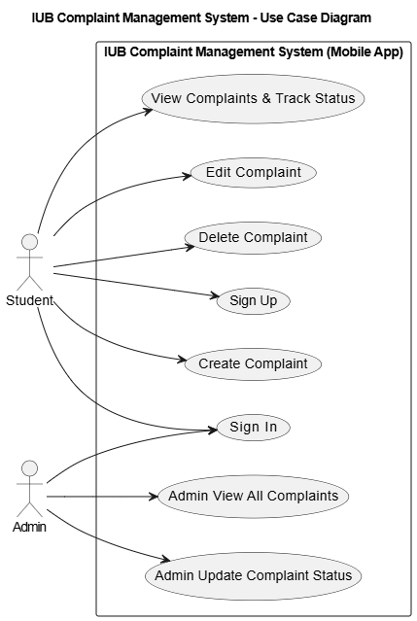
  - Use Case 1
Field | Details
ID | UC001
Name | Sign In (Email/Password)
Description | This use case describes the process flow of student sign in to access the IUB Complaint Management System.
Requirement(s) | FR002, FR-A3, FR-A4
Actor(s) | Student
Precondition | Student must have a registered account, email should be verified, and an active internet connection.
Post-condition | Student is authenticated and can access student dashboard and complaint features.
Basic Flow
- Actor opens the mobile application.
- System displays the Sign In screen.
- Actor enters credentials. 3.1. Required fields:
o 3.1.1. Email
o 3.1.2. Password
- System validates the inputs. 4.1. The system checks:
o 4.1.1. Email format (UI validation)
o 4.1.2. Required fields are not empty
- Actor taps the “Sign In” button.
- System sends credentials securely to the backend authentication service (Firebase Auth).
- On successful validation, the system authenticates the actor and checks email verification status.
- System redirects actor to Student Dashboard.
- System fetches and displays student complaints list.
Alternative Flow
A1: Forgot Password
- Actor selects “Forgot Password”.
- System asks for the registered email address.
- Actor enters email.
- System triggers password reset email link.
- Actor resets password and returns to Sign In to log in.
A2: Email Not Verified
- System displays “Email not verified”.
- Actor selects “Resend verification email”.
- System sends verification link to email.
- Actor verifies email and returns to sign in.
Exceptions
E1: Invalid Inputs
- If email format is invalid or required fields are missing, the system displays an error message and requests correction.
E2: Authentication Failed
- If credentials are incorrect, the system displays “Invalid email or password” and allows retry.
E3: Network Failure
- If the system cannot reach Firebase (no internet/service down), the system displays a network error message and provides retry.
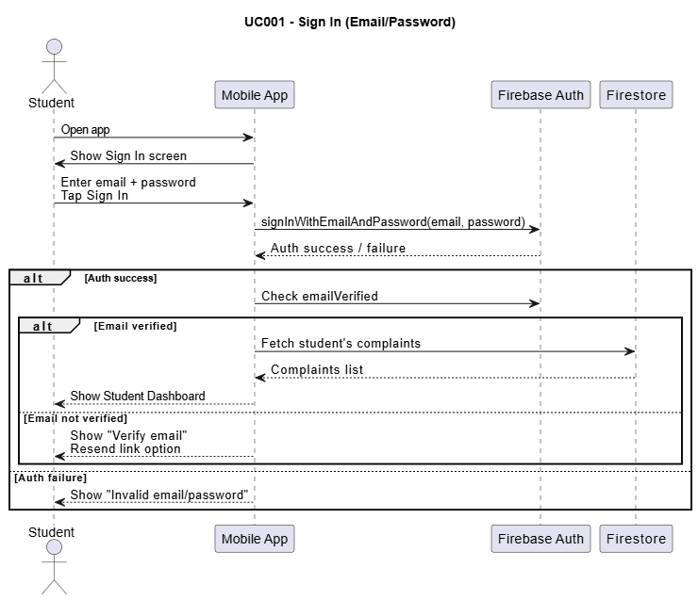
  - Use Case 2
Field | Details
ID | UC002
Name | Sign Up (Email/Password + Verification Link)
Description | This use case describes how a student creates an account and receives an email verification link.
Requirement(s) | FR001, FR-A2, FR-A5
Actor(s) | Student
Precondition | Student has a valid IUB email and an active internet connection.
Post-condition | Student account is created and verification email link is sent; student can sign in after verifying email.
Basic Flow
- Actor opens the mobile application.
- System displays Sign In screen with “Create Account” option.
- Actor selects “Create Account”.
- System displays the Sign Up form. 4.1. Required fields:
o 4.1.1. Full Name
o 4.1.2. IUB Email
o 4.1.3. Password
- System validates inputs (UI email validation and required fields).
- Actor taps “Sign Up”.
- System creates user in Firebase Authentication.
- System sends verification email link to the student.
- System displays message “Verification email sent”.
Alternative Flow
A1: Email Already Registered
- If email already exists, system displays “Email already in use”.
- Actor returns to Sign In.
A2: Resend Verification Email
- Actor selects “Resend verification email”.
- System sends verification email link again.
Exceptions
E1: Weak Password
- If password does not meet policy, system displays error and requests a stronger password.
E2: Network Failure
- System displays network error and provides retry.
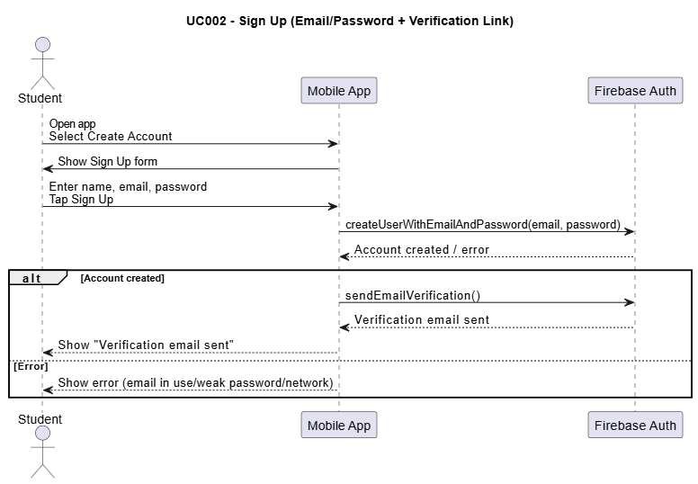
  - Use Case 3
Field | Details
ID | UC003
Name | Create Complaint
Description | This use case describes the process of submitting a new complaint by a student under fixed categories.
Requirement(s) | FR004, FR-S1, FR-S2, FR-S3
Actor(s) | Student
Precondition | Student must be signed in, email must be verified, and internet connection must be available.
Post-condition | A new complaint is stored in the database with status Pending and is visible on the student dashboard.
Basic Flow
- Actor opens the Student Dashboard.
- Actor taps the “New Complaint” button.
- System displays the complaint submission form. 3.1. Required fields:
o 3.1.1. Title
o 3.1.2. Category (fixed list)
o 3.1.3. Description
o 3.1.4. Attachment (optional)
- Actor fills in the form details.
- Actor taps the “Submit” button.
- System validates the inputs. 6.1. The system checks:
o 6.1.1. Title is not empty
o 6.1.2. Category is selected from fixed list
o 6.1.3. Description is not empty
- If attachment is selected, system uploads attachment to Firebase Storage (optional feature).
- System stores the complaint in Firestore and generates a complaint ID.
- System sets complaint status to Pending and stores createdAt timestamp.
- System displays a success message and redirects actor to the Student Dashboard.
- System refreshes dashboard and shows the newly created complaint in the list.
Alternative Flow
A1: Submit Without Attachment
- Actor leaves attachment empty.
- System skips upload step and saves complaint normally.
A2: Cancel Complaint Submission
- Actor taps “Cancel/Back” on the complaint form.
- System discards unsaved data and returns to dashboard.
Exceptions
E1: Missing Required Fields
- If required fields are missing, the system highlights the missing field(s) and shows an error message.
- Actor corrects the inputs and resubmits.
E2: Attachment Upload Failed
- If attachment upload fails, the system shows an error message.
- Actor can retry upload or submit complaint without attachment.
E3: Network Failure
- If the system cannot reach Firebase services, the system displays a network error message and provides retry.
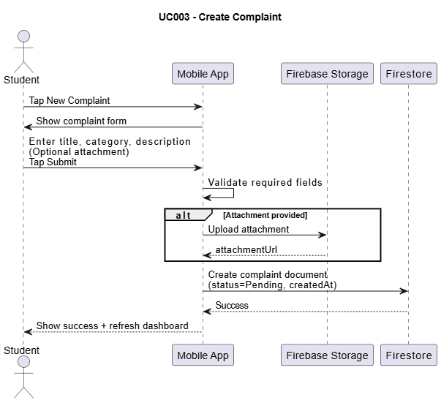
  - Use Case 4
Field | Details
ID | UC004
Name | View Complaints & Track Status (Student Dashboard)
Description | This use case describes how a student views all submitted complaints and checks their current status and details.
Requirement(s) | FR005, FR006, FR-S4, FR-S5, FR-S6
Actor(s) | Student
Precondition | Student must be signed in and have an active internet connection.
Post-condition | Student can view the complaint list and open any complaint to see its details and current status.
Basic Flow
- Actor opens the Student Dashboard.
- System fetches all complaints created by the actor from Firestore.
- System displays the complaints list with: title, category, status, and created date.
- Actor taps a complaint item to open it.
- System displays the Complaint Details screen including full description, category, current status, and timestamps.
- System displays status history (if maintained) for transparency.
Alternative Flow
A1: Filter Complaints by Status
- Actor selects a status filter (e.g., Resolved).
- System refreshes the complaint list based on selected filter.
A2: No Complaints Found
- If the student has no complaints, system displays “No complaints found” message and shows “Create Complaint” button.
Exceptions
E1: Unauthorized Access
- If actor tries to access a complaint that does not belong to them, system denies access and shows an error.
E2: Network Failure
- If the system cannot fetch data due to internet issues, system displays a network error and provides retry.
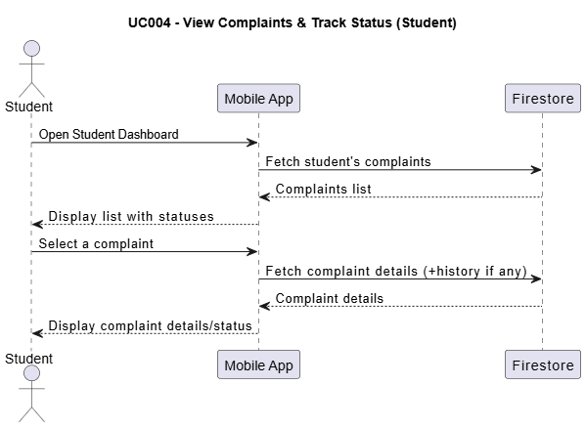
  - Use Case 5
Field | Details
ID | UC005
Name | Edit Complaint (All Statuses)
Description | This use case describes how a student edits an already submitted complaint at any status (Pending, In Progress, Resolved, Rejected).
Requirement(s) | FR007, FR-S7
Actor(s) | Student
Precondition | Student must be signed in, the complaint must belong to the student, and internet connection must be available.
Post-condition | Complaint information is updated in the database and the updated information is visible in the dashboard and complaint details screen.
Basic Flow
- Actor opens the Student Dashboard.
- Actor selects the complaint to edit.
- System displays the Complaint Details screen.
- Actor taps the “Edit” button.
- System displays the Edit Complaint form with existing values. 5.1. Editable fields:
o 5.1.1. Title
o 5.1.2. Category (fixed list)
o 5.1.3. Description
o 5.1.4. Attachment (optional)
- Actor updates one or more fields.
- Actor taps the “Save/Update” button.
- System validates the inputs. 8.1. The system checks:
o 8.1.1. Title is not empty
o 8.1.2. Category is selected
o 8.1.3. Description is not empty
- If attachment is changed, system uploads the new attachment (optional) and updates attachment URL.
- System updates the complaint record in Firestore and stores updatedAt timestamp.
- System shows a success message and returns to Complaint Details.
- System displays updated complaint information.
Alternative Flow
A1: Remove Attachment
- Actor selects “Remove Attachment”.
- System removes the attachment reference (and optionally deletes file from storage).
- System saves updated complaint without attachment.
A2: Cancel Editing
- Actor taps “Cancel/Back” while editing.
- System discards unsaved changes and returns to Complaint Details.
Exceptions
E1: Unauthorized Edit Attempt
- If actor attempts to edit a complaint that does not belong to them, system denies access and shows an error.
E2: Update Failed
- If database update fails, system shows an error message and provides retry.
E3: Network Failure
- If the system cannot reach Firebase services, system displays a network error message and provides retry.
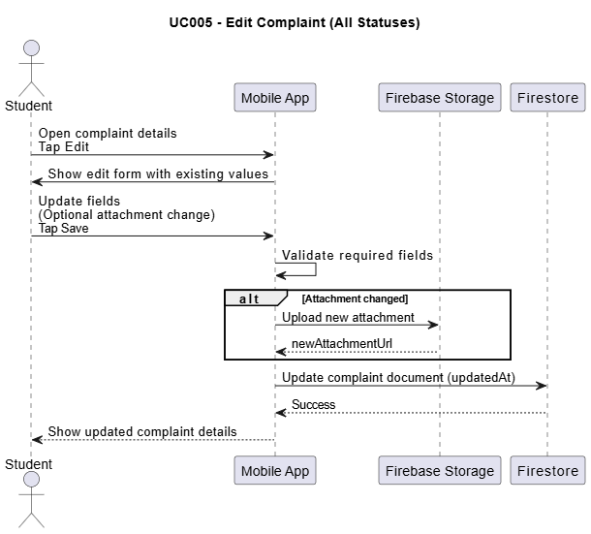
  - Use Case 6
Field | Details
ID | UC006
Name | Delete Complaint (All Statuses)
Description | This use case describes how a student deletes their complaint at any status.
Requirement(s) | FR008, FR-S8
Actor(s) | Student
Precondition | Student must be signed in, the complaint must belong to the student, and internet connection must be available.
Post-condition | The complaint is deleted/hidden from the database and no longer appears in the student dashboard.
Basic Flow
- Actor opens the Student Dashboard.
- Actor selects the complaint to delete.
- System displays the Complaint Details screen.
- Actor taps the “Delete” button.
- System displays a confirmation dialog.
- Actor confirms deletion.
- System deletes the complaint record from Firestore (or marks it as deleted if soft delete is used).
- If complaint has an attachment, system optionally deletes attachment from Firebase Storage.
- System displays a success message.
- System redirects actor to Student Dashboard.
- System refreshes the list and the deleted complaint no longer appears.
Alternative Flow
A1: Cancel Deletion
- Actor selects “Cancel/No” on confirmation dialog.
- System closes dialog and returns to Complaint Details without deleting.
A2: Soft Delete (Optional Implementation Choice)
- Instead of removing the record, system sets isDeleted = true.
- System hides deleted complaint from student dashboard results.
Exceptions
E1: Unauthorized Delete Attempt
- If actor attempts to delete a complaint that does not belong to them, system denies action and shows an error.
E2: Delete Failed
- If deletion fails, system shows an error message and provides retry.
E3: Network Failure
- If the system cannot reach Firebase services, system displays a network error message and provides retry.
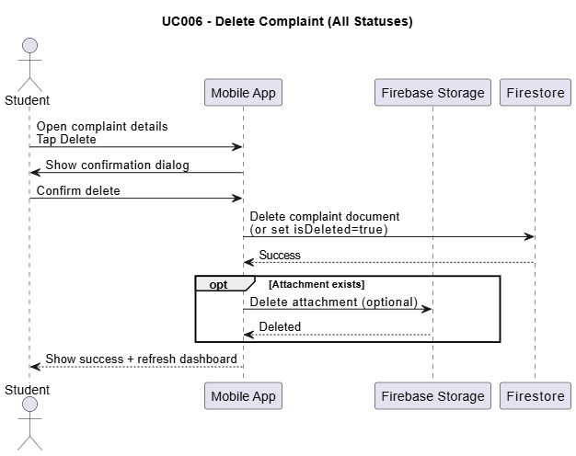
  - Use Case 7
Field | Details
ID | UC007
Name | Admin View All Complaints
Description | This use case describes how an admin views all complaints submitted by students and can search/filter them for management.
Requirement(s) | FR009, FR-AD1, FR-AD2
Actor(s) | Admin
Precondition | Admin must be signed in, must have admin role, and internet connection must be available.
Post-condition | Admin can view the list of all complaints and open any complaint to view details.
Basic Flow
- Admin opens the mobile application.
- System displays the Admin Dashboard.
- System fetches all complaints from Firestore.
- System displays a complaints list including: student email, title, category, status, and created date.
- Admin uses filter/search options. 5.1. Filter/search examples:
o 5.1.1. Filter by Status (Pending/In Progress/Resolved/Rejected)
o 5.1.2. Filter by Category
o 5.1.3. Search by Student Email / Roll No
o 5.1.4. Filter by Date (optional)
- System refreshes the list according to the selected filters/search.
- Admin selects a complaint from the list.
- System opens the Complaint Details screen for the selected complaint.
Alternative Flow
A1: No Matching Results
- If no complaints match the applied filters/search, system displays “No results found”.
- Admin can clear filters to view all complaints again.
A2: View Only Specific Status
- Admin selects a single status (e.g., Pending).
- System shows only complaints with that status.
Exceptions
E1: Unauthorized Access
- If a non-admin user tries to access Admin Dashboard, system denies access and redirects to Student Dashboard (or shows an access denied message).
E2: Data Fetch Failed
- If the system fails to fetch complaints, it displays an error message and provides retry.
E3: Network Failure
- If the system cannot reach Firebase services, system displays a network error message and provides retry.
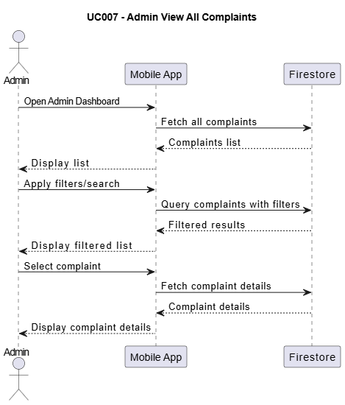
  - Use Case 8
Field | Details
ID | UC008
Name | Admin Update Complaint Status
Description | This use case describes how an admin updates the status of a complaint and optionally adds remarks for the student.
Requirement(s) | FR010, FR011, FR-AD3, FR-AD4, FR-H1
Actor(s) | Admin
Precondition | Admin must be signed in, must have admin role, complaint must exist, and internet connection must be available.
Post-condition | Complaint status is updated in the database and a status history record is stored; student can see the updated status.
Basic Flow
- Admin opens Admin Dashboard.
- Admin selects a complaint to manage.
- System displays Complaint Details screen with current status.
- Admin taps “Update Status”.
- System displays status update options. 5.1. Inputs:
o 5.1.1. New Status (Pending / In Progress / Resolved / Rejected)
o 5.1.2. Remarks (optional)
- Admin selects the new status and enters remarks (optional).
- Admin taps “Save/Update”.
- System validates the inputs. 8.1. The system checks:
o 8.1.1. A valid status is selected
- System updates the complaint status in Firestore and updates updatedAt timestamp.
- System creates a new record in complaint status history (oldStatus → newStatus, admin info, timestamp, remarks).
- System displays a success message and refreshes complaint details showing updated status.
Alternative Flow
A1: Update Without Remarks
- Admin leaves remarks empty and updates status.
- System updates status and stores history record without remarks.
A2: No Status Change
- Admin selects the same status as current status.
- System may either (a) allow save and still log history, or (b) show message “No change detected” (implementation choice).
Exceptions
E1: Status Not Selected
- If admin does not select a status, system shows error “Please select a status” and does not save.
E2: Update Failed
- If Firestore update fails, system shows an error message and provides retry.
E3: Network Failure
- If the system cannot reach Firebase services, system displays a network error message and provides retry.
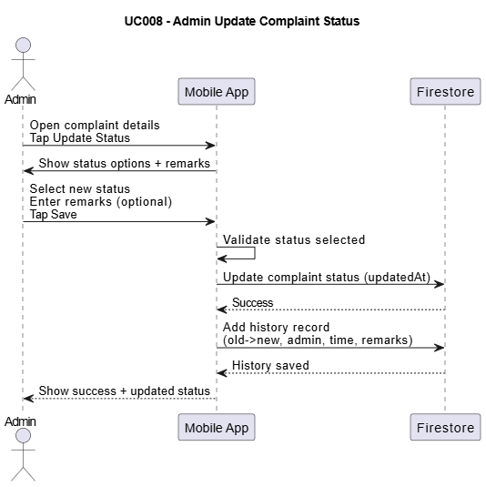
- References
[1] IEEE Computer Society, IEEE Std 830-1998: IEEE Recommended Practice for Software Requirements Specifications. New York, NY, USA: IEEE, 1998.
[2] IEEE Computer Society, ISO/IEC/IEEE 29148:2018—Systems and Software Engineering—Life Cycle Processes—Requirements Engineering. IEEE, 2018.
[3] Google, “Firebase Documentation,” Google Developers, 2026. [Online]. Available: https://firebase.google.com/docs. [Accessed: May 01, 2026].
[4] Google, “Firebase Authentication Documentation,” Google Developers, 2026. [Online]. Available: https://firebase.google.com/docs/auth. [Accessed: May 01, 2026].
[5] Google, “Cloud Firestore Documentation,” Google Developers, 2026. [Online]. Available: https://firebase.google.com/docs/firestore. [Accessed: May 01, 2026].
[6] Google, “Firebase Cloud Storage Documentation,” Google Developers, 2026. [Online]. Available: https://firebase.google.com/docs/storage. [Accessed: May 01, 2026].
[7] Google, “Firebase Security Rules Documentation,” Google Developers, 2026. [Online]. Available: https://firebase.google.com/docs/rules. [Accessed: May 01, 2026].
[8] Google, “Flutter Documentation,” Flutter, 2026. [Online]. Available: https://docs.flutter.dev/. [Accessed: May 01, 2026].
[9] M. Fowler, “Patterns of Enterprise Application Architecture (Service Layer / Repository Concepts),” MartinFowler.com, 2002. [Online]. Available: https://martinfowler.com/eaaCatalog/. [Accessed: May 01, 2026].
[10] Atlassian, “Jira Service Management Documentation (Ticketing/Issue Tracking Concepts),” Atlassian, 2026. [Online]. Available: https://support.atlassian.com/jira-service-management/. [Accessed: May 01, 2026].

